UUNIT-2

ARTIFICIAL NEURAL NETWORKS

**CONTENT**

**Introduction**

Neural Network Representation

Appropriate Problems for Neural Network Learning

Perceptrons

Multilayer Networks and BACKPROPAGATION Algorithms

Remarks on the BACKPROPAGATION Algorithms

INTRODUCTION

Artificial neural networks (ANNs) provide a general, practical method for learning real-valued,

discrete-valued, and vector-valued target functions from examples.

Biological Motivation

The study of artificial neural networks (ANNs) has been inspired by the observation that biological learning systems are built of very complex webs of interconnected Neurons

Human information processing system consists of brain neuron: basic building block cell that communicates information to and from various parts of body

Simplest model of a neuron: considered as a threshold unit –a processing element (PE)

Collects inputs & produces output if the sum of the input exceeds an internal

threshold value

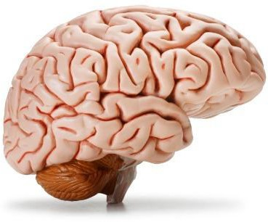

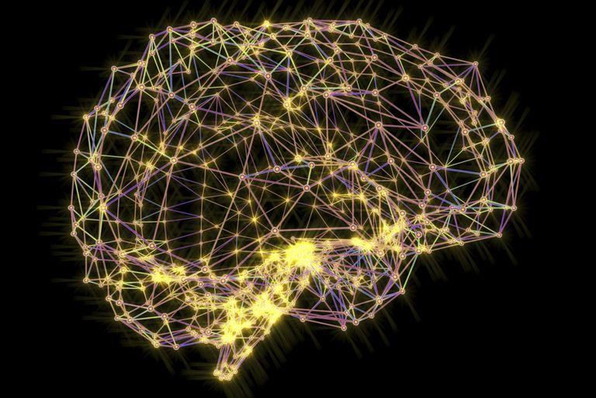

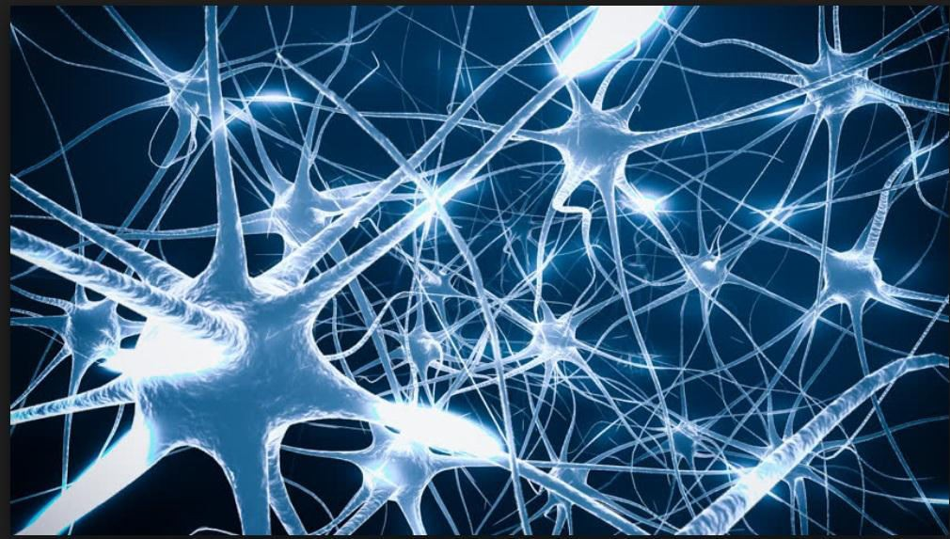

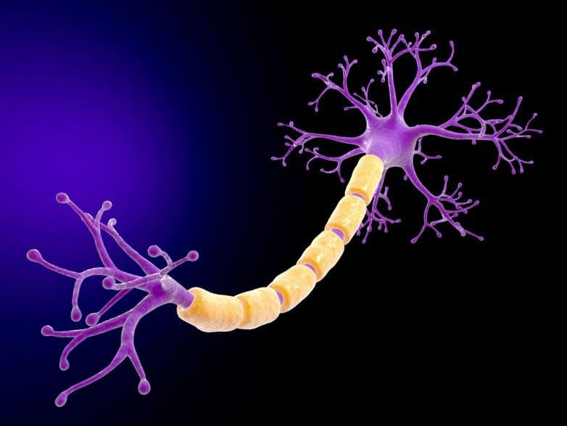

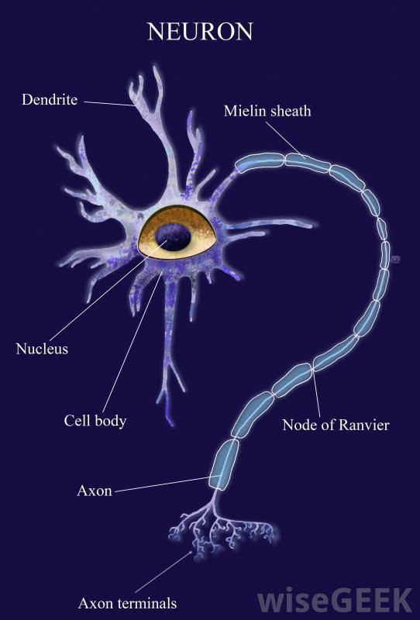

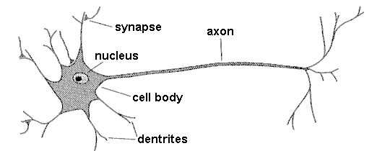

**synapse**

**axon**

**nucleus**

**cell body**

**dendrites**

Facts of Human Neurobiology

Number of neurons ~ 1011

Connection per neuron ~ 10 4 – 5

Neuron switching time ~ 0.001 second or 10 -3

Scene recognition time ~ 0.1 second

100 inference steps doesn’t seem like enough

Highly parallel computation based on distributed representation

Properties of Neural Networks

Many neuron-like threshold switching units

Many weighted interconnections among units

Highly parallel, distributed process

Emphasis on tuning weights automatically

Input is a high-dimensional discrete or real-valued (e.g, sensor input)

When to consider Neural Networks ?

Input is a high-dimensional discrete or real-valued (e.g., sensor input)

Output is discrete or real-valued

Output is a vector of values

Possibly noisy data

Form of target function is unknown

Human readability of result is unimportant

Examples:

Speech phoneme recognition

Image classification

Financial perdition

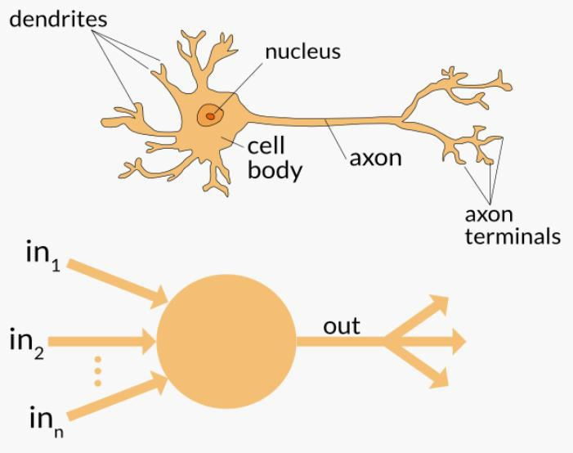Neuron

Neuron

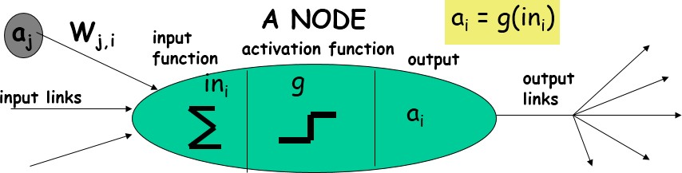

Neuron

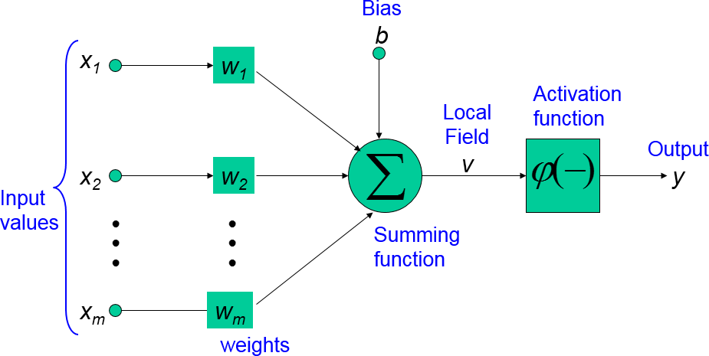

Neuron

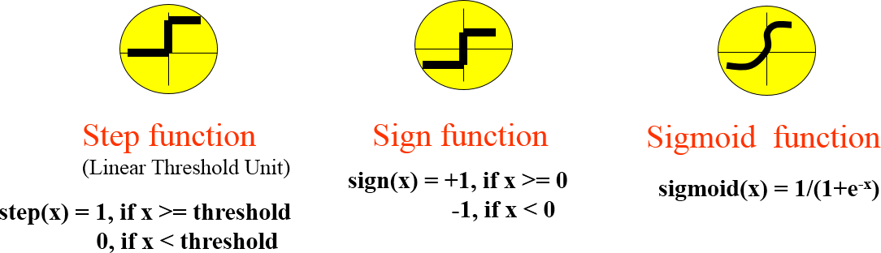

NEURAL NETWORK REPRESENTATIONS

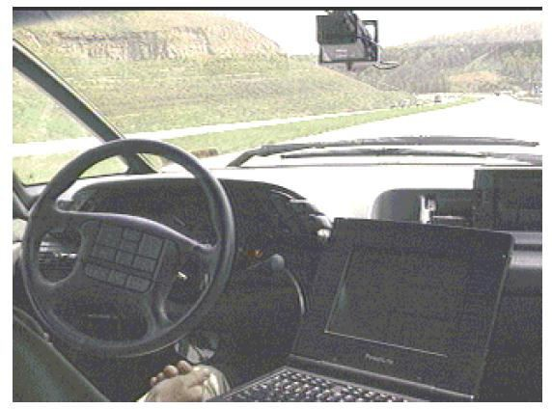

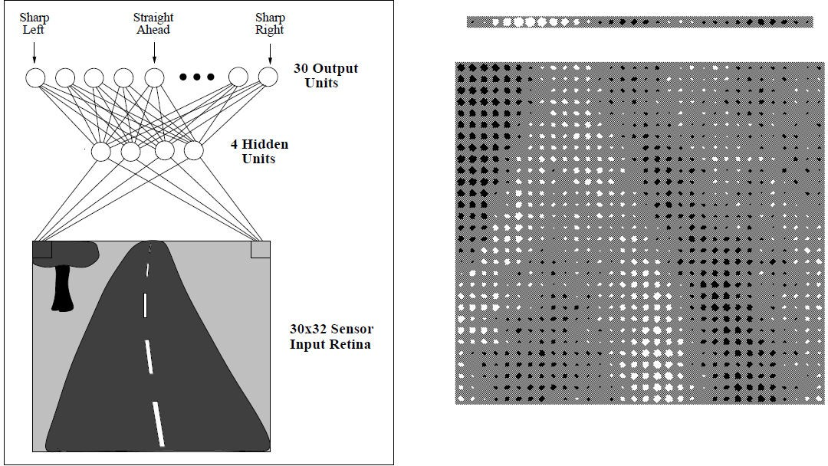

A prototypical example of ANN learning is provided by Pomerleau's (1993) system ALVINN, which uses a learned ANN to steer an autonomous vehicle driving at normal speeds on public highways.

The input to the neural network is a 30x32 grid of pixel intensities obtained from a forward-pointed camera mounted on the vehicle.

The network output is the direction in which the vehicle is steered.

Figure illustrates the neural network representation.

The network is shown on the left side of the figure, with the input camera image depicted below it.

Each node (i.e., circle) in the network diagram corresponds to the output of a

single network unit, and the lines entering the node from below are its inputs.

There are four units that receive inputs directly from all of the 30 x 32 pixels in the image. These are called "hidden" units because their output is available only within the network and is not available as part of the global network output. Each of these four hidden units computes a single real-valued output based on a weighted combination of its 960 inputs

These hidden unit outputs are then used as inputs to a second layer of 30 "output"

units.

Each output unit corresponds to a particular steering direction, and the output values of these units determine which steering direction is recommended most strongly.

The diagrams on the right side of the figure depict the learned weight values associated with one of the four hidden units in this ANN.

The large matrix of black and white boxes on the lower right depicts the weights from the 30 x 32 pixel inputs into the hidden unit. Here, a white box indicates a positive weight, a black box a negative weight, and the size of the box indicates the weight magnitude.

The smaller rectangular diagram directly above the large matrix shows the weights from this hidden unit to each of the 30 output units.

APPROPRIATE PROBLEMS FOR

NEURAL NETWORK LEARNING

ANN is appropriate for problems with the following characteristics :

Instances are represented by many attribute-value pairs.

The target function output may be discrete-valued, real-valued, or a vector of several real- or discrete-valued attributes.

The training examples may contain errors.

Long training times are acceptable.

Fast evaluation of the learned target function may be required

The ability of humans to understand the learned target function is not important

Architectures of Artificial Neural Networks

An artificial neural network can be divided into three parts (layers), which are known as:

Input layer: This layer is responsible for receiving information (data), signals, features, or measurements from the external environment. These inputs are usually normalized within the limit values produced by activation functions

Hidden, intermediate, or invisible layers: These layers are composed of neurons which are responsible for extracting patterns associated with the process or system being analysed. These layers perform most of the internal processing from a network.

Output layer : This layer is also composed of neurons, and thus is responsible for producing and presenting the final network outputs, which result from the processing performed by the neurons in the previous layers.

Architectures of Artificial Neural Networks

The main architectures of artificial neural networks, considering the neuron disposition, how they are interconnected and how its layers are composed, can be divided as follows:

Single-layer feedforward network

Multi-layer feedforward networks

Recurrent or Feedback networks

Mesh networks

Single-Layer Feedforward Architecture

This artificial neural network has just one input layer and a single neural layer, which is also the output layer.

Figure illustrates a simple-layer feedforward network composed of n inputs and m outputs.

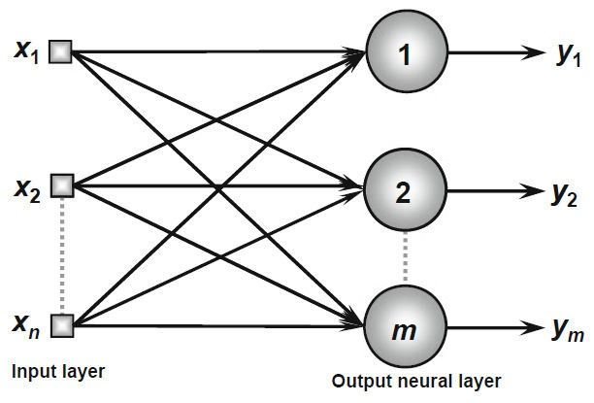The information always flows in a single direction (thus, unidirectional), which is from the input layer to the output layer

Multi-Layer Feedforward Architecture

This artificial neural feedforward networks with multiple layers are composed of one or more hidden neural layers.

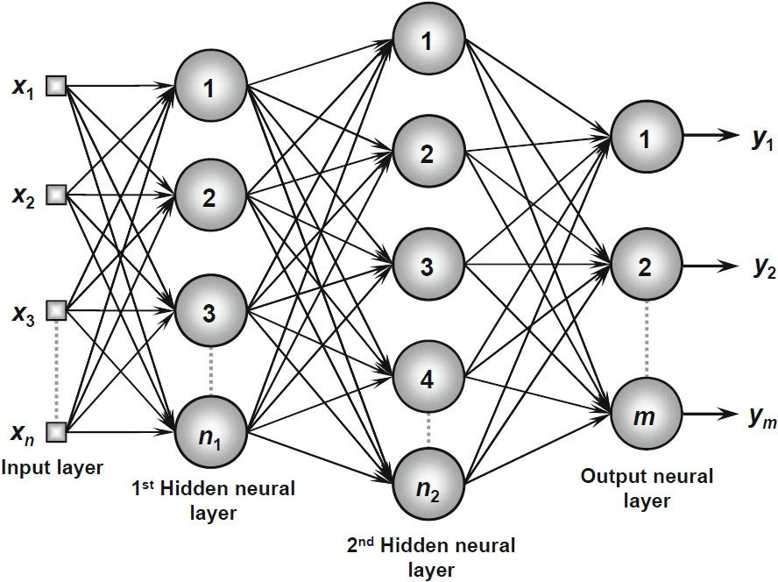Figure shows a feedforward network with multiple layers composed of one input layer with n sample signals, two hidden neural layers consisting of n1 and n2 neurons respectively, and, finally, one output neural layer composed of m neurons representing the respective output values of the problem being analyzed

.

Recurrent or Feedback Architecture

In these networks, the outputs of the neurons are used as feedback inputs for other neurons.

Figure illustrates an example of a Perceptron network with feedback, where one of its output

signals is fed back to the middle layer.

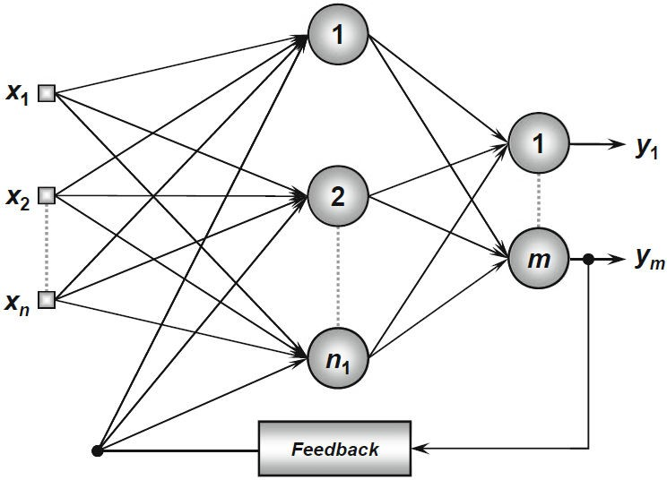

Mesh Architectures

The main features of networks with mesh structures reside in considering the spatial arrangement of neurons for pattern extraction purposes, that is, the spatial localization of the neurons is directly related to the process of adjusting their synaptic weights and thresholds.

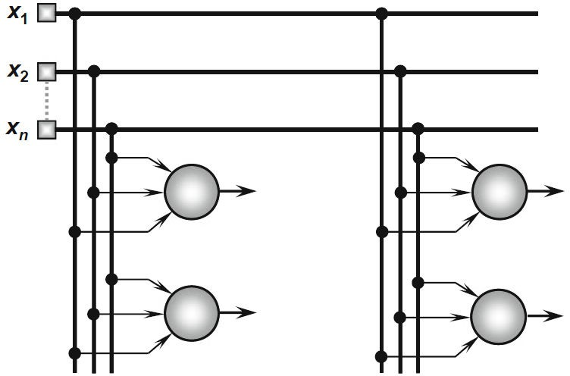Figure illustrates an example of the Kohonen network where its neurons are arranged within a two- dimensional space

PERCEPTRONS

Perceptron is a single layer neural network.

A perceptron takes a vector of real-valued inputs, calculates a linear combination of these inputs, then outputs a 1 if the result is greater than some threshold and -1 otherwise

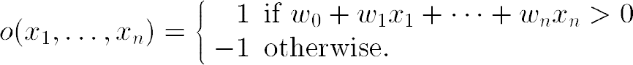Given inputs x1 through xn, the output O(x1, . . . , xn) computed by the perceptron is

where each wi is a real-valued constant, or weight, that determines the contribution

of input xi to the perceptron output.

-w0 is a threshold that the weighted combination of inputs w1x1 + . . . + wnxn must surpass in order for the perceptron to output a 1.

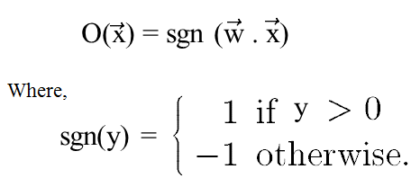Sometimes, the perceptron function is written as,

Learning a perceptron involves choosing values for the weights w0 , . . . , wn . Therefore, the space H of candidate hypotheses considered in perceptron learning is the set of all possible real-valued weight vectors



Why do we need Weights and Bias?

Weights shows the strength of the particular node.

A bias value allows you to shift the activation function curve up or down

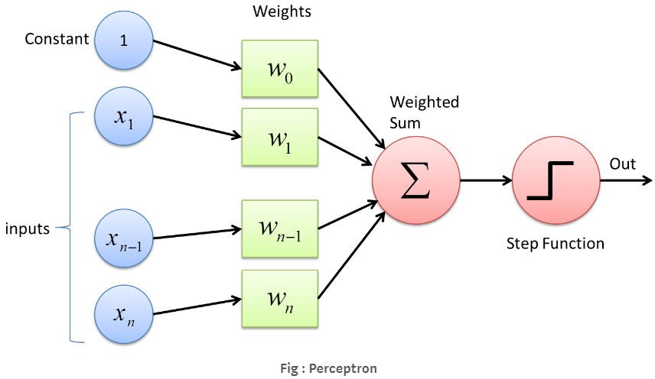

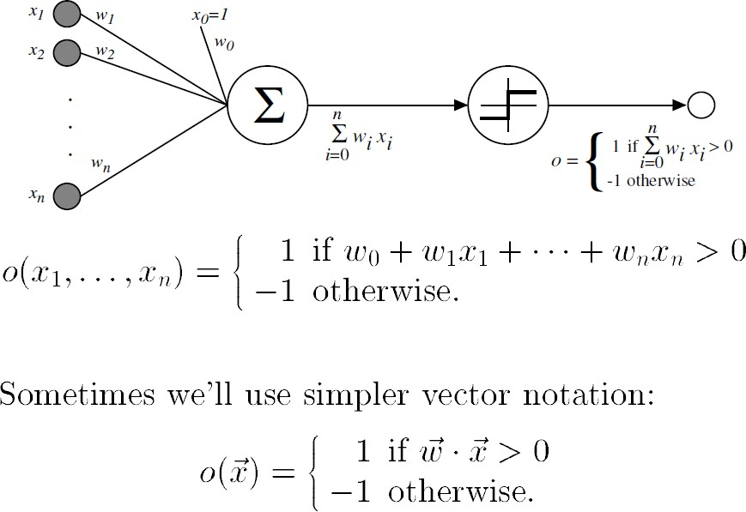

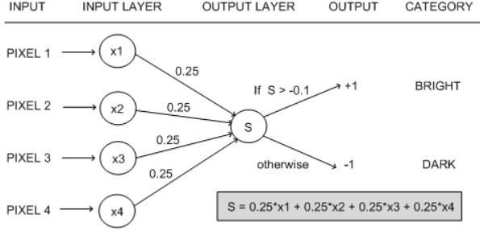

Representational Power of Perceptrons

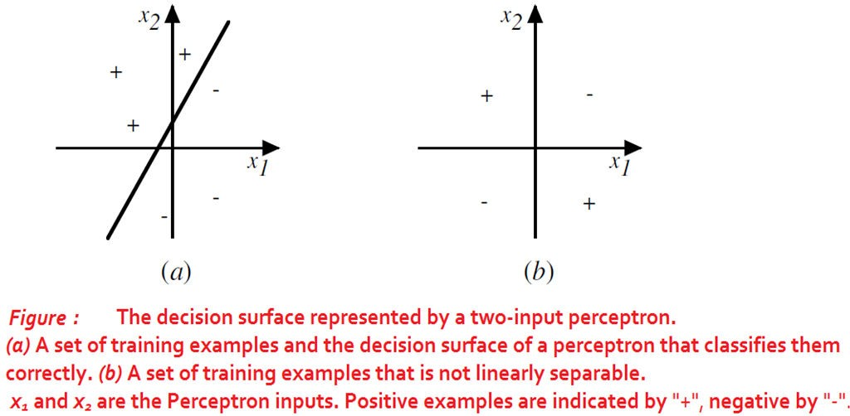The perceptron can be viewed as representing a hyperplane decision surface in the n-dimensional space of instances.

The perceptron outputs a 1 for instances lying on one side of the hyperplane and outputs a -1 for instances lying on the other side

A single perceptron can be used to represent many Boolean functions

AND function

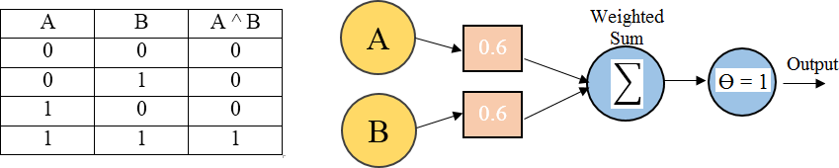

If A=0 & B=0 → 0*0.6 + 0*0.6 = 0.

This is not greater than the threshold of 1, so the output = 0.

If A=0 & B=1 → 0*0.6 + 1*0.6 = 0.6.

This is not greater than the threshold, so the output = 0.

If A=1 & B=0 → 1*0.6 + 0*0.6 = 0.6.

This is not greater than the threshold, so the output = 0.

If A=1 & B=1 → 1*0.6 + 1*0.6 = 1.2.

This exceeds the threshold, so the output = 1.

The Perceptron Training Rule

The learning problem is to determine a weight vector that causes the perceptron to produce the correct + 1 or - 1 output for each of the given training examples.

To learn an acceptable weight vector

Begin with random weights, then iteratively apply the perceptron to each training

example, modifying the perceptron weights whenever it misclassifies an example.

This process is repeated, iterating through the training examples as many times as needed until the perceptron classifies all training examples correctly.

Weights are modified at each step according to the perceptron training rule, which revises the weight wi associated with input xi according to the rule.

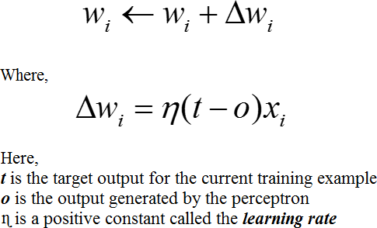

The role of the learning rate is to moderate the degree to which weights are changed at each step. It is usually set to some small value (e.g., 0.1) and is sometimes made to decay as the number of weight-tuning iterations increases

Drawback: The perceptron rule finds a successful weight vector when the training examples are linearly separable, it can fail to converge if the examples are not linearly separable.

Gradient Descent and the Delta Rule

If the training examples are not linearly separable, the delta rule converges toward a best-fit approximation to the target concept.

The key idea behind the delta rule is to use gradient descent to search the hypothesis space of possible weight vectors to find the weights that best fit the training examples.

To understand the delta training rule, consider the task of training an unthresholded

perceptron. That is, a linear unit for which the output O is given by

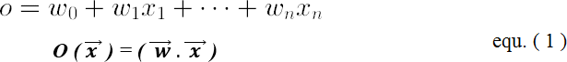

To derive a weight learning rule for linear units, specify a measure for the training error of a hypothesis (weight vector), relative to the training examples.



Where,

D is the set of training examples,

td is the target output for training example d,

od is the output of the linear unit for training example d

E [ w ] is simply half the squared difference between the target output td and the linear unit output od, summed over all training examples.

Visualizing the Hypothesis Space

To understand the gradient descent algorithm, it is helpful to visualize the entire hypothesis space of possible weight vectors and their associated E values as shown in below figure.

Here the axes w0 and wl represent possible values for the two weights of a simple linear unit. The w0, wl plane therefore represents the entire hypothesis space.

The vertical axis indicates the error E relative to some fixed set of training

examples.

The arrow shows the negated gradient at one particular point, indicating the direction in the w0, wl plane producing steepest descent along the error surface.

The error surface shown in the figure thus summarizes the desirability of every weight vector in the hypothesis space

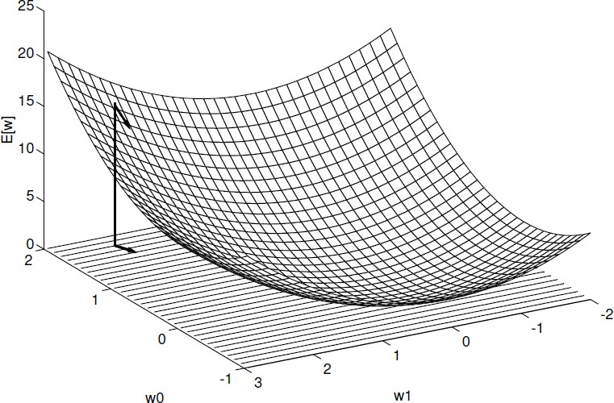

Given the way in which we chose to define E, for linear units this error surface must always be parabolic with a single global minimum.

Gradient descent search determines a weight vector that minimizes E by starting with an arbitrary

initial weight vector, then repeatedly modifying it in small steps.

At each step, the weight vector is altered in the direction that produces the steepest descent along the error surface depicted in above figure. This process continues until the global minimum error is reached.

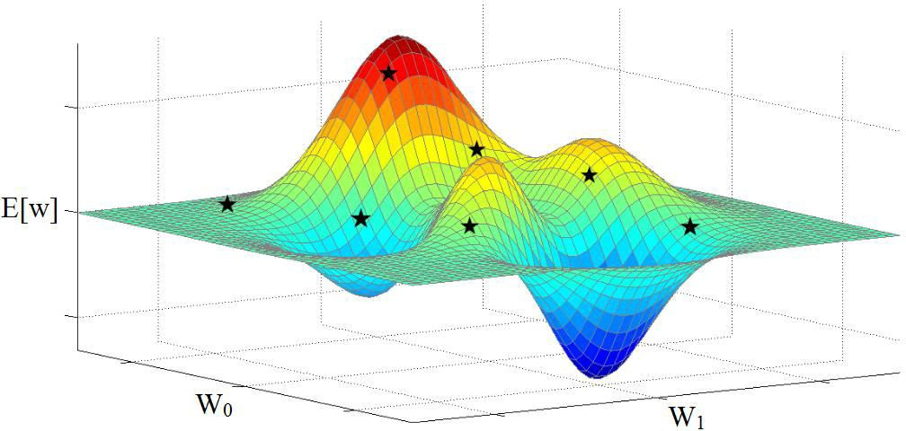

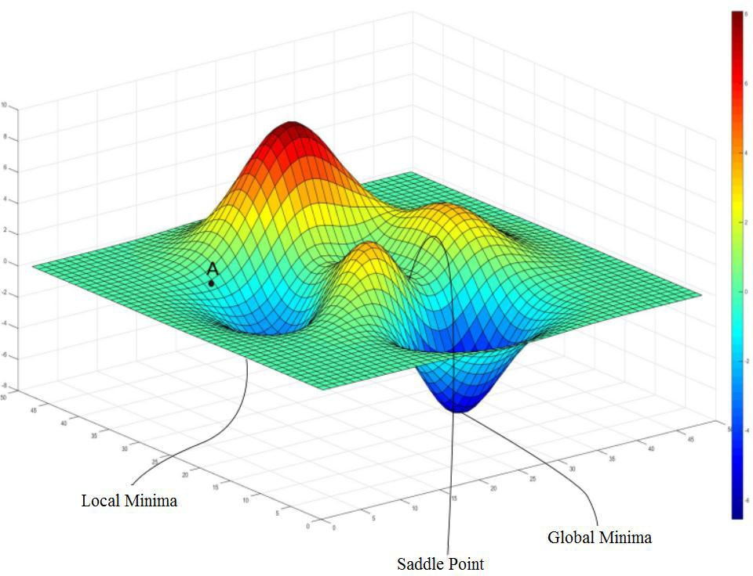

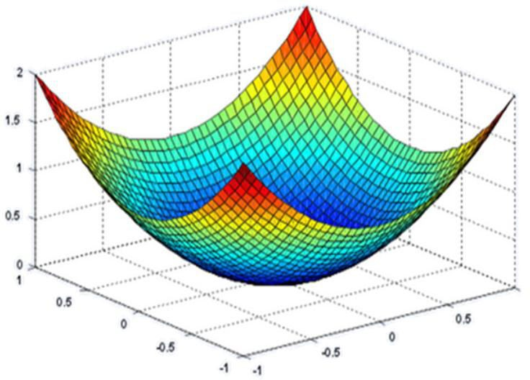

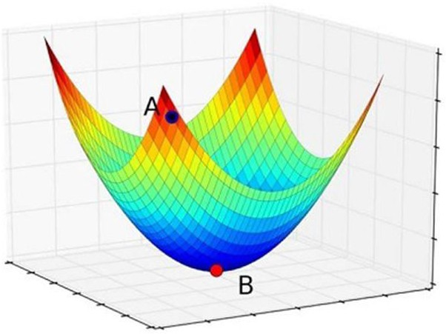

Derivation of the Gradient Descent Rule

How to calculate the direction of steepest descent along the error surface?

The direction of steepest can be found by computing the derivative of E with respect to each component of the vector w . This vector derivative is called the gradient of E with respect to w , written as

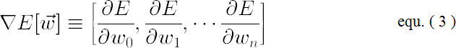

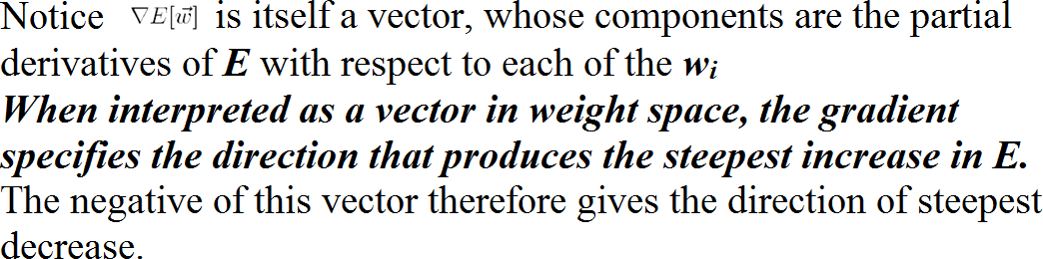

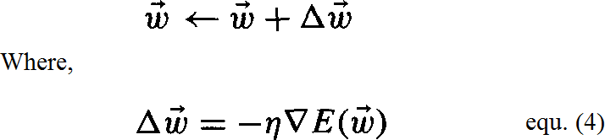The gradient specifies the direction of steepest increase of E, the training rule for gradient descent is

Here η is a positive constant called the learning rate, which determines the step

size in the gradient descent search.

The negative sign is present because we want to move the weight vector in the direction that decreases E

This training rule can also be written in its component form

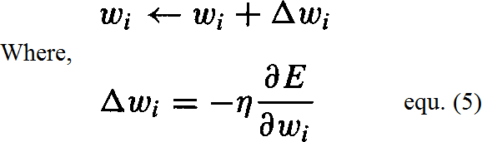

Calculate the gradient at each step. The vector of 𝜕𝐸

𝜕𝑤𝑖

derivatives that form the gradient can be obtained by

differentiating E from Equation (2), as

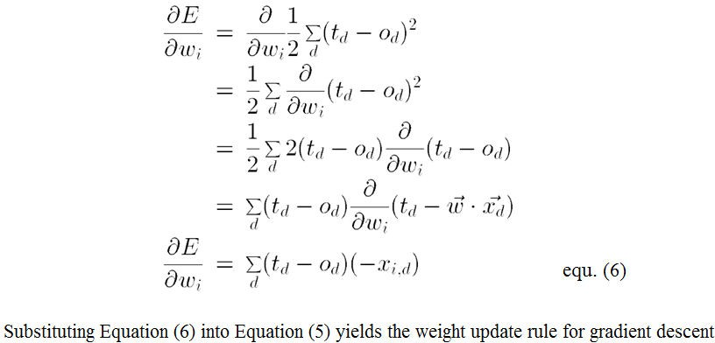



GRADIENT DESCENT algorithm for training a linear unit

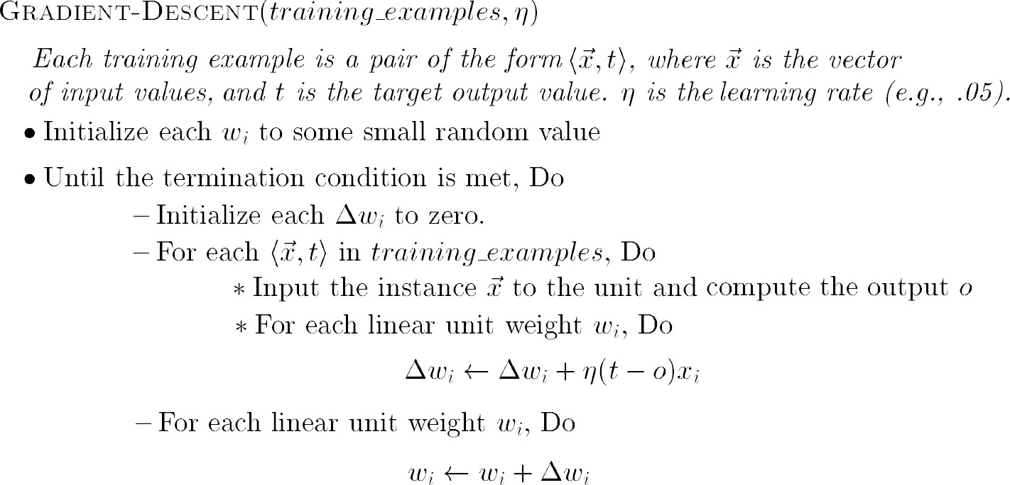

To summarize, the gradient descent algorithm for training linear units is as follows:

Pick an initial random weight vector.

Apply the linear unit to all training examples, then compute Δwi for each weight according to Equation (7).

Update each weight wi by adding Δwi, then repeat this process

Features of Gradient Descent Algorithm

Gradient descent is an important general paradigm for learning. It is a strategy for searching through a large or infinite hypothesis space that can be applied whenever

The hypothesis space contains continuously parameterized hypotheses

The error can be differentiated with respect to these hypothesis parameters

The key practical difficulties in applying gradient descent are

Converging to a local minimum can sometimes be quite slow

If there are multiple local minima in the error surface, then there is no guarantee that the procedure will find the global minimum

Stochastic Approximation to Gradient Descent

The gradient descent training rule presented in Equation (7) computes weight updates after summing over all the training examples in D

The idea behind stochastic gradient descent is to approximate this gradient descent search by updating weights incrementally, following the calculation of the error for each individual example



where t, o, and xi are the target value, unit output, and ith input for the training example in question

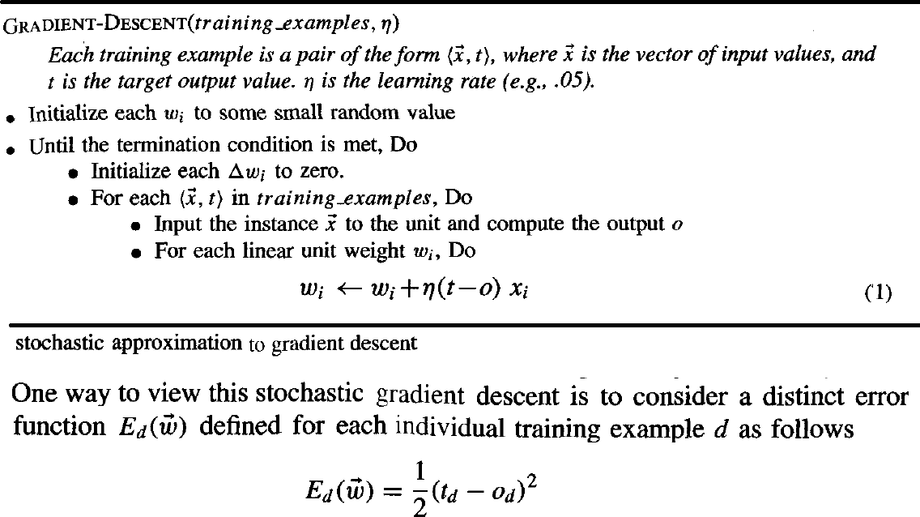

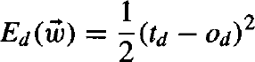One way to view this stochastic gradient descent is to consider a distinct error function Ed ( w ) for each individual training example d as follows

Where, td and od are the target value and the unit output value for training example d.

Stochastic gradient descent iterates over the training examples d in D, at each iteration altering the weights according to the gradient with respect to Ed( w )

The sequence of these weight updates, when iterated over all training examples, provides a reasonable approximation to descending the gradient with respect to our original error function Ed ( w )

By making the value of η sufficiently small, stochastic gradient descent can be made to approximate true gradient descent arbitrarily closely

The key differences between standard gradient descent and stochastic gradient descent are

In standard gradient descent, the error is summed over all examples before updating weights, whereas in stochastic gradient descent weights are updated upon examining each training example.

Summing over multiple examples in standard gradient descent requires more computation per weight update step. On the other hand, because it uses the true gradient, standard gradient descent is often used with a larger step size per weight update than stochastic gradient descent.

In cases where there are multiple local minima with respect to stochastic gradient descent can sometimes avoid falling into these local minima because it uses the various 𝛻Ed ( w ) rather than 𝛻E ( w ) to guide its search

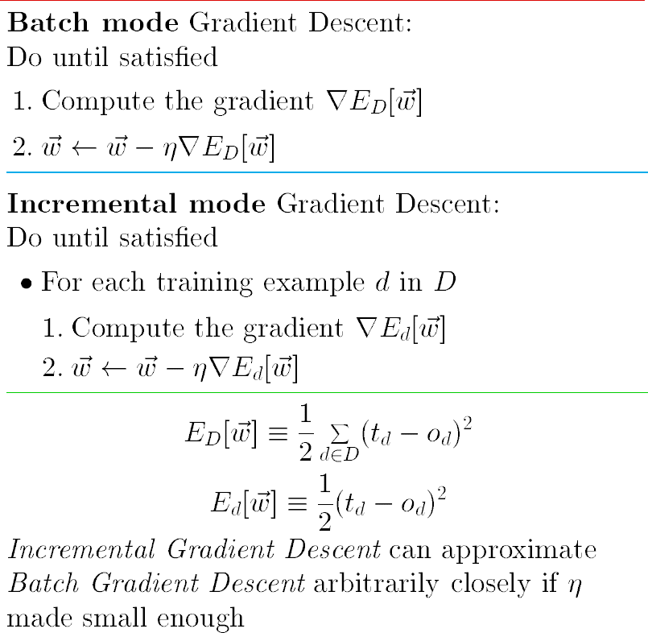

MULTILAYER NETWORKS AND THE BACKPROPAGATION ALGORITHM

Multilayer networks learned by the BACKPROPACATION algorithm are capable

of expressing a rich variety of nonlinear decision surfaces

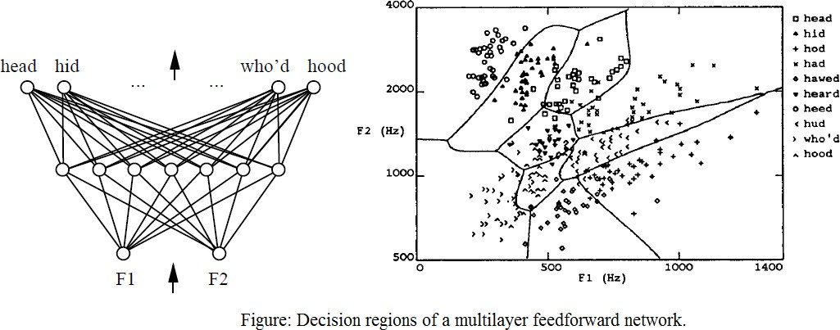

Decision regions of a multilayer feedforward network. The network shown here was trained to recognize 1 of 10 vowel sounds occurring in the context "h_d" (e.g., "had," "hid"). The network input consists of two parameters, F1 and F2, obtained from a spectral analysis of the sound. The 10 network outputs correspond to the 10 possible vowel sounds. The network prediction is the output whose value is highest.

The plot on the right illustrates the highly nonlinear decision surface represented by the learned network. Points shown on the plot are test examples distinct from the examples used to train the network.

A Differentiable Threshold Unit

Sigmoid unit-a unit very much like a perceptron, but based on a smoothed, differentiable threshold function.

The sigmoid unit first computes a linear combination of its inputs, then applies a threshold to the result. In the case of the sigmoid unit, however, the threshold output is a continuous function of its input.

More precisely, the sigmoid unit computes its output O as

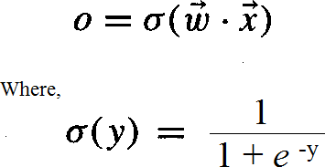

σ is the sigmoid function

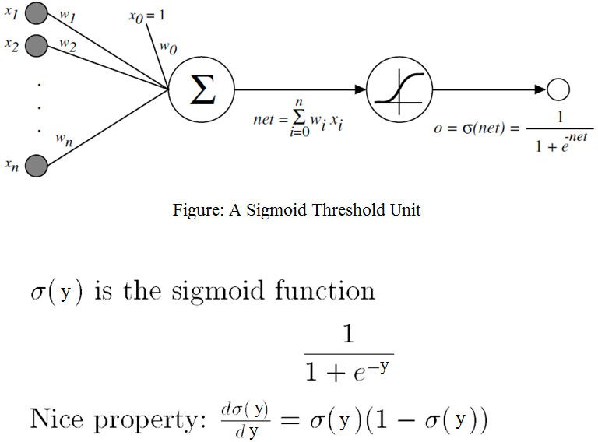

The BACKPROPAGATION Algorithm

The BACKPROPAGATION Algorithm learns the weights for a multilayer network, given a network with a fixed set of units and interconnections. It employs gradient descent to attempt to minimize the squared error between the network output values and the target values for these outputs.

In BACKPROPAGATION algorithm, we consider networks with multiple output units rather than single units as before, so we redefine E to sum the errors over all of the network output units.

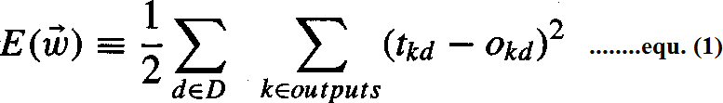

where,

outputs - is the set of output units in the network

tkd and Okd - the target and output values associated with the kth output unit

d - training example

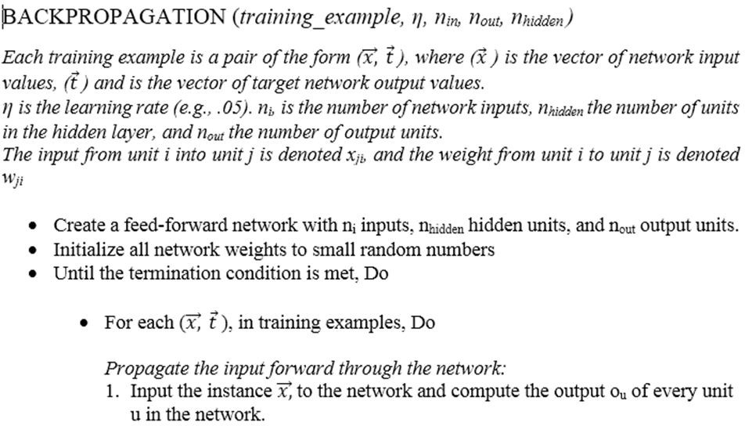

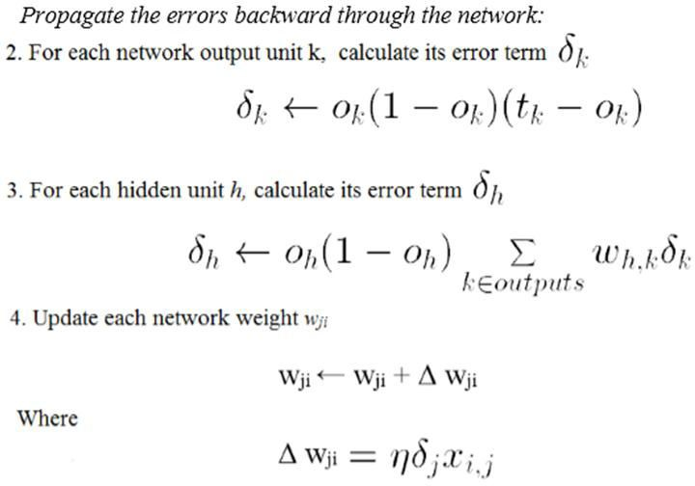

Derivation of the BACKPROPAGATION Rule

Deriving the stochastic gradient descent rule: Stochastic gradient descent involves iterating through the training examples one at a time, for each training example d descending the gradient of the error Ed with respect to this single example

For each training example d every weight wji is updated by adding to it Δ wji

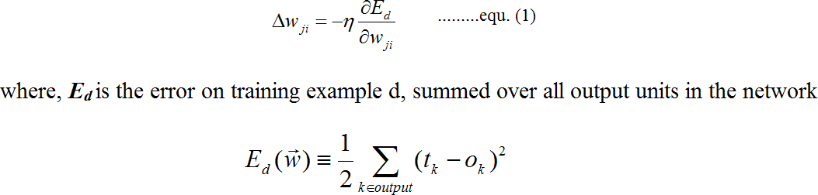

Here outputs is the set of output units in the network, tk is the target value of unit k for

training example d, and ok is the output of unit k given training example d.

The derivation of the stochastic gradient descent rule is conceptually straightforward, but requires keeping track of a number of subscripts and variables

xji = the ith input to unit j

wji = the weight associated with the ith input to unit j netj = Σi wjixji (the weighted sum of inputs for unit j ) oj = the output computed by unit j

tj = the target output for unit j

σ = the sigmoid function

outputs = the set of units in the final layer of the network

Downstream(j) = the set of units whose immediate inputs include the output of unit j

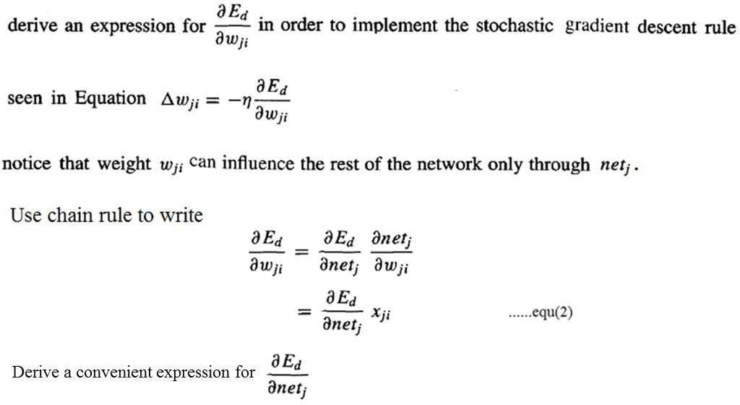

Consider two cases in turn: the case where unit j is an output unit for the network, and the case where j is an

internal unit (hidden unit).

Case 1: Training Rule for Output Unit Weights.

wji can influence the rest of the network only through netj , netj can influence the network only through oj.

Therefore, we can invoke the chain rule again to write

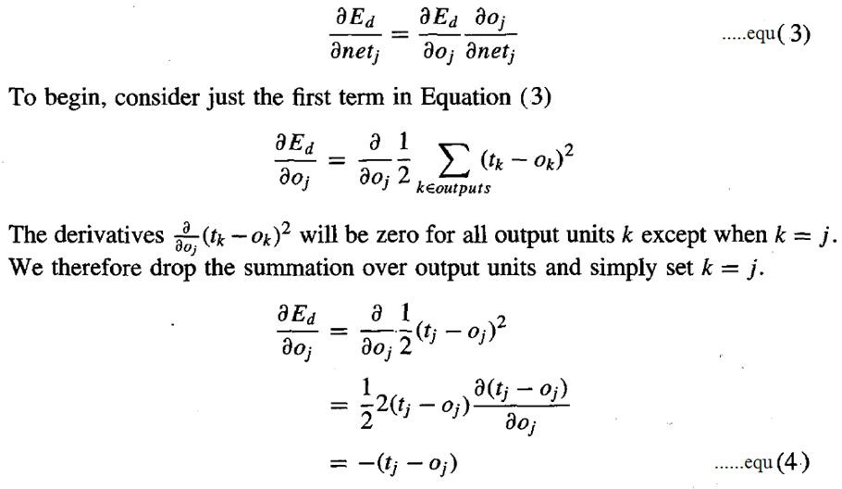

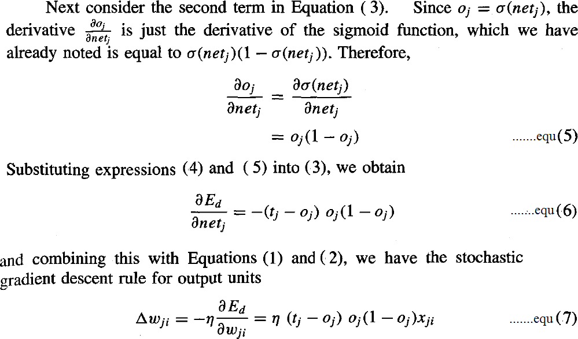

Case 2: Training Rule for Hidden Unit Weights.

In the case where j is an internal, or hidden unit in the network, the derivation of the training rule for wji must take into account the indirect ways in which wji can influence the network outputs and hence Ed.

For this reason, we will find it useful to refer to the set of all units immediately downstream of unit j in the network and denoted this set of units by Downstream( j).

netj can influence the network outputs only through the units in Downstream(j).

Therefore, we can write

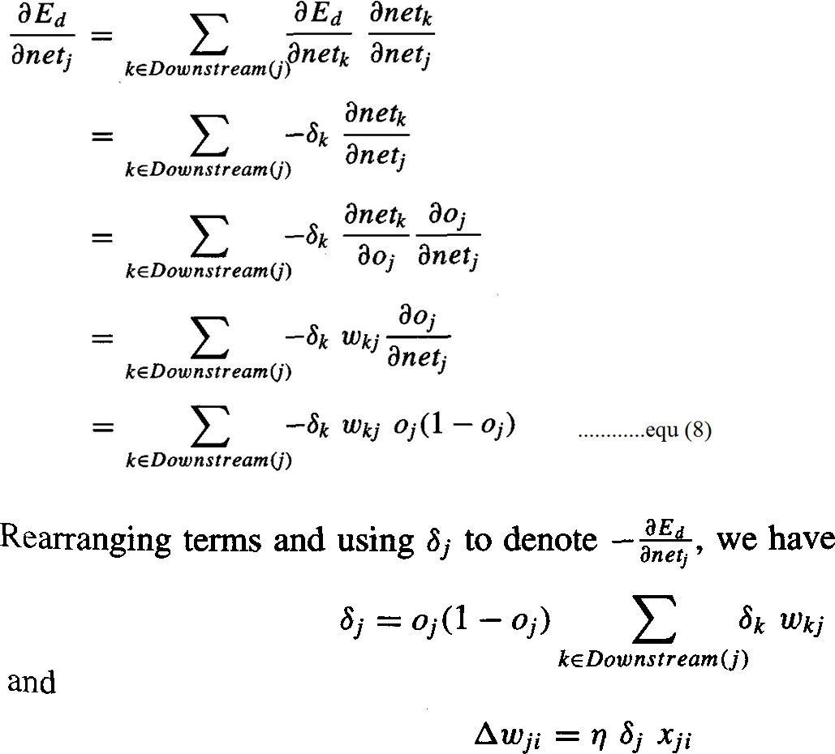

REMARKS ON THE BACKPROPAGATION ALGORITHM

1. Convergence and Local Minima

The BACKPROPAGATION multilayer networks is only guaranteed to converge toward some local minimum in E and not necessarily to the global minimum error.

Despite the lack of assured convergence to the global minimum error, BACKPROPAGATION is a highly effective function approximation method in practice.

Local minima can be gained by considering the manner in which network weights evolve as the number of training iterations increases.

Common heuristics to attempt to alleviate the problem of local minima include:

Add a momentum term to the weight-update rule. Momentum can sometimes carry the gradient descent procedure through narrow local minima

Use stochastic gradient descent rather than true gradient descent

Train multiple networks using the same data, but initializing each network with different random weights

2. Representational Power of Feedforward Networks

What set of functions can be represented by feed-forward networks?

The answer depends on the width and depth of the networks. There are three quite general results are known about which function classes can be described by which types of Networks

Boolean functions – Every boolean function can be represented exactly by some network with two layers of units, although the number of hidden units required grows exponentially in the worst case with the number of network inputs

Continuous functions – Every bounded continuous function can be approximated with arbitrarily small error by a network with two layers of units

Arbitrary functions – Any function can be approximated to arbitrary accuracy by a network with three layers of units.

Hypothesis Space Search and Inductive Bias

Hypothesis space is the n-dimensional Euclidean space of the n network weights and hypothesis space is continuous.

As it is continuous, E is differentiable with respect to the continuous parameters of the hypothesis, results in a well-defined error gradient that provides a very useful structure for organizing the search for the best hypothesis.

It is difficult to characterize precisely the inductive bias of BACKPROPAGATION algorithm, because it depends on the interplay between the gradient descent search and the way in which the weight space spans the space of representable functions. However, one can roughly characterize it as smooth interpolation between data points.

Hidden Layer Representations

BACKPROPAGATION can define new hidden layer features that are not explicit in the input representation, but which capture properties of the input instances that are most relevant to learning the target function.

Consider example, the network shown in below Figure

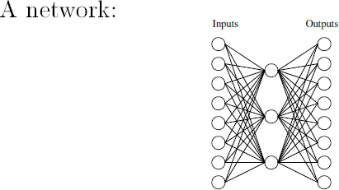

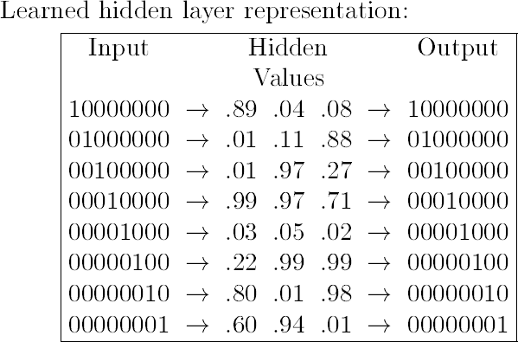

Consider training the network shown in Figure to learn the simple target function f

(x) = x, where x is a vector containing seven 0's and a single 1.

The network must learn to reproduce the eight inputs at the corresponding eight output units. Although this is a simple function, the network in this case is constrained to use only three hidden units. Therefore, the essential information from all eight input units must be captured by the three learned hidden units.

When BACKPROPAGATION applied to this task, using each of the eight possible vectors as training examples, it successfully learns the target function. By examining the hidden unit values generated by the learned network for each of the eight possible input vectors, it is easy to see that the learned encoding is similar to the familiar standard binary encoding of eight values using three bits (e.g., 000,001,010,. . . , 111). The exact values of the hidden units for one typical run of shown in Figure.

This ability of multilayer networks to automatically discover useful representations at the hidden layers is a key feature of ANN learning

Generalization, Overfitting, and Stopping Criterion

What is an appropriate condition for terminating the weight update loop?

One choice is to continue training until the error E on the training examples falls below some predetermined threshold.

To see the dangers of minimizing the error over the training data, consider how the error E varies with the number of weight iterations

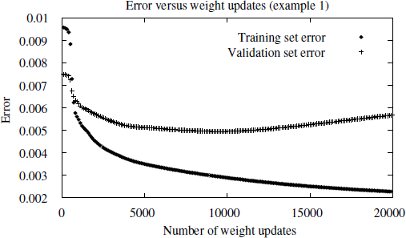

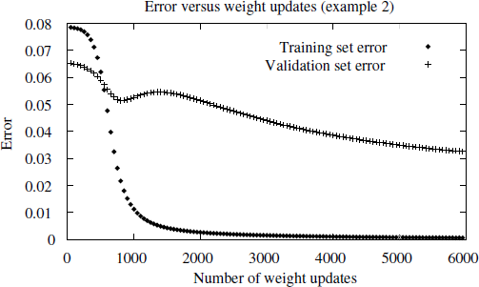

Consider first the top plot in this figure. The lower of the two lines shows the monotonically decreasing error E over the training set, as the number of gradient descent iterations grows. The upper line shows the error E measured over a different validation set of examples, distinct from the training examples. This line measures the generalization accuracy of the network-the accuracy with which it fits examples beyond the training data.

The generalization accuracy measured over the validation examples first decreases, then increases, even as the error over the training examples continues to decrease. How can this occur? This occurs because the weights are being tuned to fit idiosyncrasies of the training examples that are not representative of the general distribution of examples. The large number of weight parameters in ANNs provides many degrees of freedom for fitting such idiosyncrasies

Why does overfitting tend to occur during later iterations, but not during earlier iterations?

By giving enough weight-tuning iterations, BACKPROPAGATION will often be able to create overly complex decision surfaces that fit noise in the training data or unrepresentative characteristics of the particular training sample.

THANK YOU